Be a Counselor for 2020 Camp Connections at Massanetta Springs!
* Build lasting friendships * Lead Outdoor Adventures with Children and Youth *
* Serve the Church * Grow in Christ *
* Foster Fun, Fellowship and Faith *

Who Can Apply? Completed junior and seniors in High School and College Students.

When will it be? Camp Connections is held in conjunction with the Bible and Church Music Conference at Massanetta Springs and Netta Day Camp’s music week. New counselors will arrive Saturday morning, July 25, 2020 (for training and meeting with the full time summer staff) and will leave on Saturday, August 1, 2020.

Where will we live? Camp Connections counselors live together with the full time summer staff either at Camp Massanetta or in Petersburg Cottage.

What will I be doing? You will be leading a group of children or youth throughout their Camp Connections day. The week will include art, choir, handbell, and orff rehearsals (all led by clinicians), a daily Bible Study, games, and camp adventures (all led by you!). We will provide the training. You will be working with a partner counselor all week.

Massanetta Springs provides our Camp Connections Counselors with food and lodging, training and supplies for the work you will do, and an honorarium of $200.00.

Interested in joining the team?
Please fill out the application below and return it to hannaha@massanettasprings.org. **Applications are accepted on a rolling basis until all positions are filled.**

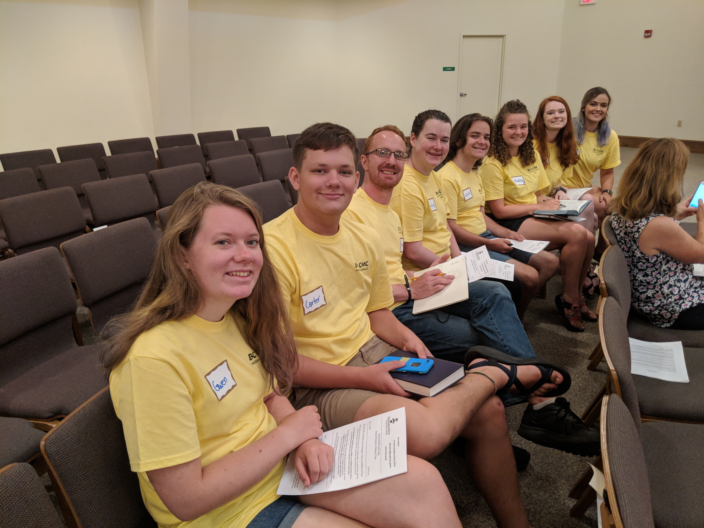
Massanetta Springs
Camp Connections
Counselor Application 2020
Name: Click here to enter text.
Address: Click here to enter text.
Click here to enter text.
Email: Click here to enter text.
Cell Phone: Click here to enter text. Home Phone: Click here to enter text.
Current Year in High School: Click here to enter text. OR
Name of College (if collegiate): Click here to enter text.
Home Church: Click here to enter text.
When have you been to Massanetta Springs? Click here to enter text.

Please answer the following questions:

- Tell us about YOU—
- If this is your FIRST TIME TO APPLY: What do you enjoy doing, where are you a student, what is one fact about you that helps us know you better, and what is your previous experience working with kids (don’t worry, no experience is necessary, we just like to know)? Click here to enter text.
- If you are a RETURNING APPLICANT, update us on this past year: Where have you been? What’s new? How’s life? We truly care about this past year and all that has happened, so share up! Click here to enter text.
- Something amazing happens when we pull together a great group of young leaders who live and serve together. Why you are applying to serve at Massanetta as a Counselor this summer? Click here to enter text. What is one hope you have for the week? Click here to enter text. What is one of your strengths and where do you need to grow? Click here to enter text. Share with us a time when you felt overwhelmed, what did you do? Click here to enter text.
- Working with youth can be challenging. Each youth adds a different personality to the group making the dynamics tricky at times. What are some ways you would ensure everyone is part of the group and having a great time? Click here to enter text.]

- Would you best be suited to lead a small group of Preschool, Elementary, Middle School, or High School aged conferees? Share with us an activity you might do with children/youth of this age group to teach or help explore their faith. Click here to enter text.
Please return completed application by May 11, 2020 to:
Hannah Altman
Massanetta Springs Camp & Conference Center
712 Massanetta Springs Road
Harrisonburg, VA 22801
Phone #: 540-434-3829 Fax #: 540-433-6118
www.massanettasprings.org hannaha@massanettasprings.org

